PATIENT EXPERINCE – Patient Participation Scheme DES

Step 1 – Develop a Patient Participation Group (PRG)

Edgwick Medical Patient Participation Group has been meeting regularly since our first meeting help on the 27th September 2012.

Efforts to make PPG representative across the patient population.
For the first meeting administrative staff and Doctors at the practice came up with a list of patients to invite. At this meeting it was made clear that the ownership of the PPG must be with the PPG and the group is open to any patient at our surgery.
Since this initial meeting in September 2012 there have been many people joining and others leaving the PPG. As of Feb 2014 our PPG consists of 7 regular attendees with another 10 patient who do attend meetings, but infrequently.
Our panel consist of the following patients.
Chairperson – Mrs Margret Campbell (Age 64),
Secretary –
Members - Mrs Irena Johnson (Age 64), currently works within the primary care sector.
Mrs Shahina Khatoon (Age ), carer and mother of ? children living in Foleshill.
Mr Michael Breslin (Age 71)
Mr Brent Richardson (Age 71),
Mrs Manjeet Mangat (Age 66), registered at surgery since 2003
Mr Syed Ali (Age 23), student at Coventry University

Formal Terms of Reference agreed
In a meeting of the PPG on 30th of May 2013, our PPG developed and committed to its own ‘Terms of Reference’ namely to;
The Patient Panel will work collaboratively with the practice to:
- Represent the views of patients
- Act as a link between the patient population and the practice
- Ensure practice development reflects the diverse needs of the patient population
- Reach agreement on resolution to problems that is equitable and achievable
- Interpret patient feedback to support action planning
- Suggest areas of improvement, both physical improvements (building space) and health services
- Understand internal and external pressures on the practice and relay these to both patients and the practice
- Represent the practice at wider patient forums and other PPG’s in the area
- Feedback to the practice on matters affecting patient care
- Support the practices ‘health and well being strategy’ to improve the health of the patient population
- Influence the provision of secondary healthcare and social care locally
- conduct patient surveys from time to time
- This list is not exhaustive and shall from time to time be updated

Methods used to inform all patients about the PPG and how to get involved

Existing PPG members – the best tool for recruiting new members was word of mouth by the existing members. Existing members would come to the practice and spend time sitting in the waiting areas informing other patients about the PPG and whether they would like to join. -

NHS Choices – Information about our PPG is detailed on our NHS Choices web pages as is the report relating the previous PPG survey.

Practice’s own website - Information about our PPG and its function is detailed on our own web site www.edgwickmedical.nhs.uk, as is the report relating to the previous PPG survey. We have had patients emailing us who would like to join the PPG and others who would just like regular updates.

Complaints received from patients – Most complaint letters are received from people who care about our services, when replying to these complaint letters we always invite people to make their voices herd through the PPG, an example of an actual paragraph of a letter is:
…….. “If you would like to join our Patient Participation Group we are having our next meeting on the 27th of September at 6.30 at the practice, here you will have an opportunity to shape the services that we offer in a more formal way.”……

Right hand side of patient scripts – We have advertised the PPG on the right hand side of patient scripts, inviting people to join.

Practice Information Booklet – There is a detailed section in the Practice Information Booklet about the work of our PPG and how to join (available to everybody in reception and given to new patients).

Practice Newsletters – We produce 4 newsletters per year and there is always an article about the current work that the PPG is doing.

Posters around the surgery – Posters are displayed around the surgery explaining the work of the PPG and how it is an open invitation for any patient to join.

One-to-one contact with all staff including the Doctors and Nurses – All our staff including the GP’s inform our patients about the existence of our PPG and how they can get involved in shaping the services they receive.

Step 2 – Agree areas of priority with the PPG (2013-2014)

A meeting of the PPG was convened on the 15th August 2013, it was agreed that the areas of priority would be agreed at this meeting. Both the GP partners were present at this meeting. The agenda for the meeting was as below:

Agenda
- Welcome and Introductions
- Minutes of last meeting.
- Discuss the process of conduction our 2013 practice survey
- Agree areas of Priority for questions that will be asked in survey
  - Patient priorities and issues
e.g. clinical care
getting an appointment
reception issues
opening times
parking
waiting times
  - Practice priorities and issues including themes from complaints
  - Planned practice changes
Talks about a merger with Henley Green Medical Centre
  - National GP patient Survey issues
There areas where we performed poor are:
Ease of getting through to someone at GP surgery on the phone (75% - 47%)
Helpfulness of receptionists at GP surgery (88% - 62%)
Frequency of seeing preferred GP (63% -37)
Impression of waiting time at surgery (9% - 20%)
Able to get an appointment to see or speak to someone (86% - 53%)
Overall experience of making an appointment (76% - 49%)
Rating of GP giving you enough time (86% - 72%)
GP is good at listening (88% - 75%)
Overall experience of GP surgery (87% - 71%)
Recommending GP surgery to someone who has just moved to the local area (80% - 51%)

Lengthy discussions took place around many of the agenda items. Discussions around item 4.4 caused some heated debate amongst the PPG members, most members of the PPG were very surprised at the results of the National Patient Survey, members firmly believed that this did not reflect a true picture of the surgery and its ability to cater for the diverse needs of its patients. It was thus agreed by all members that Edgwick would use this years Patient survey to conduct its own research using exactly the same 10 questions (that we had performed poorly) as the National patient survey. PPG members were confident that the picture painted by the national survey was incorrect and were passionate about finding out the true picture.

We help from the Practice Manager the exact wording of the 2013-2014 survey was also finalised within this meeting. The 15 questions would be :

About You
Q1: Please tell us the year you were born?
Q2: Please tell us your post code?
Q3: Gender?
About the Surgery
Q4: How easy is it to get through to someone at the GP Surgery on the phone?
Q5: How helpful do you find the receptionist at the Surgery?
Q5: How easy was it to get an appointment to see or speak to someone?
Q6: What is your overall experience of making an appointment?
Q7: How easy was it to get an appointment with the GP that you want?
Q8: How long after your appointment time do you normally wait to be seen?
Q9: The last time you saw a Dr at the surgery how good was the Dr at each of the following?
Please put a tick in one box for each row
Giving you enough time
Asking about your symptoms
Listening to what you have to say
Explaining tests and treatments
Involving you in decisions about your care
Treating you with care, concern & dignity
Taking your problems seriously
Q10: In general, how satisfied are you with the care you get at the surgery ?
Q11: Would you recommend the Surgery to someone who has just moved to your local area?
Q12: Do you know how to make a complaint/suggestion regarding your Doctors Surgery?
Q13: Please tell us below any other ways that you could improve your services at the Doctors Surgery?
Q14: What is your ethnic group?
Q15: Do you have any disabilities?

Also agreed in this meeting was a timetable of events that would see the printing of the surveys’, their completion and the compilation and distribution of the results. Each PPG member was allocated different times to come in and sit with patients to complete the surveys.

Step 3 – Collate patient views through the use of a survey

It was agreed right on outset that Edgwick staff would not take part in getting patients to complete the surveys, the PPG wanted to make sire that the survey was completely independent of the staff, patients would feel mre comfortable an would ‘open up’ more to fellow patients.

As a guide we aimed to get 25 out of every 1000 patients on our practice list to complete one of these surveys, our current list size is 4300, i.e. we should aim to get at least 108 survey completed. Over the months of September, October and November PPG members completed 202 Patient Surveys, nearly double the required amount.

Most of the 202 completed surveys were done here in the surgery; most people completed surveys while waiting for appointments or just after coming out of a consultation. PPG members gave up their valuable time by sitting in the waiting areas and handing out surveys attached to clip boards and helped anybody who needed help, PPG members did not help people to answer the questions or influence their answers. A few forms were taken away and returned at a later date. The results of each and every questions contained within the survey are detailed and analysed into a report in January 2014.

Step 4 – Provide PPG with opportunity to discuss survey findings and reach agreement with the PPG on changes to service.
&
Step 5 – Agree action plan with the PPG and seek PPG agreement to implementing changes

A survey is only as good as the information collected, which, in turn, only as good as what is done with this information. It was a key part of the whole process that the results of the survey were shared back with the PPG and a list of action points developed, these action points would then need addressing my the group together with the practice.

The Practice Manager took all 208 surveys and collated the information into easy to understand data in the form of graphs and tables. Once an ‘easy to understand’ report had been compiled, it was then presented to the PPG a meeting held on the 6th of February 2014 for discussion. After much lengthy discussions around the responses to the questions received the following action points were agreed by the PPG. Just like last year, the PPG decided to split the actions into two distinct groups; those action points which could be implemented relatively quickly, we called these ‘Quick wins’ and those that would take longer and may require more strategic or perhaps required a culture change, we called these ‘Long Term Goals’.

It was also agreed by PPG members at this meeting that our own Patient Survey went a long way to challenge some of the results of the National Survey, this point was fed back to Martina Ellery, Contracts Manager, Arden, Herefordshire and Worcestershire Area Team, NHS England. At a PMF Performance visit by Martina Ellery on the 29th of November 2013 the results of the National Survey was discussed at great lengths as well as the intentions of our PPG to complete their own survey.

Action Plan - ‘QUICK WINS’
In response to Question | Action point | Who is responsible | Date for completion
Q13 – more appointment availability  Q7 – seeing preferred GP  Q11- Recommending practice to others | We have the maximum about of GP time which is affordable to the surgery, we now need to look at the timetable of the GP’s and see if any improvement can be made in order to give more appointments.  Look at possibilities of more telephone consultation slots. | Deputy Practice Manager | End of March 2014
Q9.1 – GP giving enough time during consultations  Q11- Recommending practice to others | Discuss with GP partners about making 15 min sessions instead of 10 min sessions. | Deputy Practice Manager | End of March 2014

Action plan - ‘LONG TERM GOALS’
In response to Question | Action point | Who is responsible | Date for completion
Q5. - Helpfulness of receptionist  Q6. - Overall experience of making an appointment  Q11 - Recommending practice to others  Q12 – patients knowing how to make a complaint | Arrange staff training for all reception staff. | Practice Manager | End of Dec 2014
Q.4 – ease of getting through on the phone.  Q5.1 – how easy was it get appointment.  Q6 – overall experience of making and appointment  Q11- Recommending practice to others | Automated phone answering system to guide people to the correct line i.e  Press ‘one’ for appointments  Press ‘two’ for prescriptions  Etc.. | Practice Manager | End of June 2014

Step 6 – Publicise actions taken – and subsequent achievement

This report together with the survey results have been publicised on our own web pages www.edgwickmedical.nhs.uk as well as HNHS Choices

These reports together with the survey results have been posted out in the waiting areas of the surgery see pictures.

These reports are made available to any patient who enquires after seeing the posters around the practice.

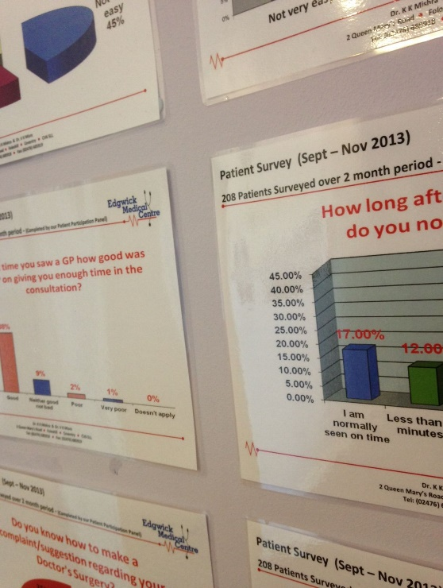
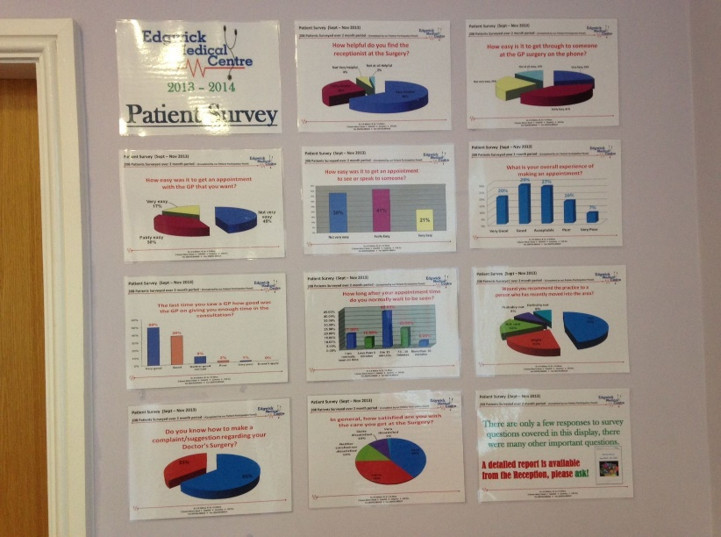

1st Floor waiting Area

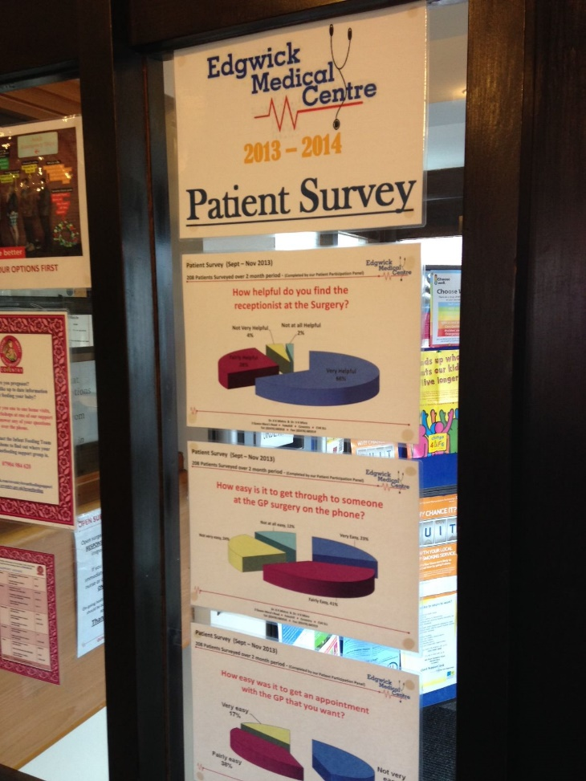
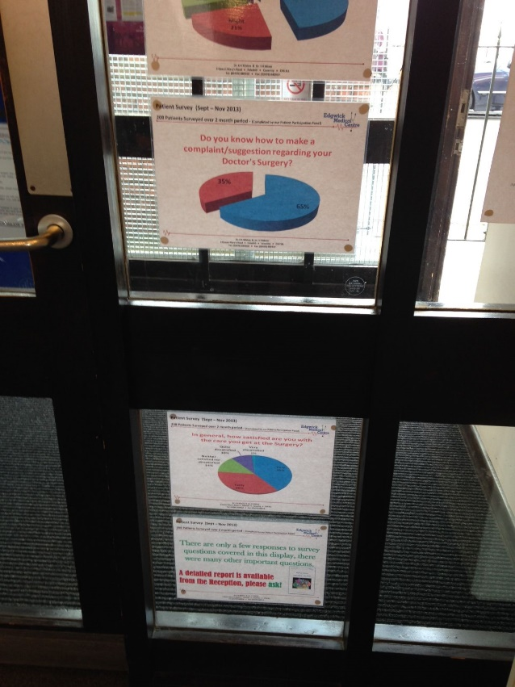

Ground floor waiting area

